FIELD & COMPANY

Box 433

Mamaroneck, N.Y.10543

914-698-4751

Catalogue of steam and mechanical models

Winter-Spring 1974-5

All items are offered subject to prior sale. Prices stated herein are guaranteed until May 1,1975. Orders must be accompanied by payment in full in the form of cashier's or certified check, or by postal money order. Prices are F.0.B. Mamaroneck, New York and do not include packing or insurance. Shipping, packing and insurance charges for specific items will be promptly communicated upon request and must be added to the cost of the item ordered. New York State Residents should also add the sales tax prevailing in their community to the list price of the item ordered. Black and white photos of items not illustrated in this catalogue will be sent on receipt of a self-addressed envelope (8" x 10" please) together with 25¢ per photo desired; for color slides, send $1 per slide together with a conventional correspondence envelope.

N.B. Dimensions stated herein are overall, and include bases and plinths where they exist. While measurements are close, they are not precise.

#101 Inverted, marine, single cylinder engine. Castings supplied by Stevens model Dockyard. Maker unknown. Circa 1880. Mahogany base.7 5/8" L, 5 3/8" H, 4" w. $170

#102 Rare model of vertical, oscillating, twin-cylinder steam deck winch. Controls include main stop valve; steam-port reversing box and lever; lubricator; brake; dog-clutch lever. Made circa 1900 by Reverend D. Martin of Bath, England, who poured most of his own castings, using an incinerator in his churchyard as his heat source. Wood base. 10 3/8" L, 5 5/16" H, 8 ¼ W. $ $600

#l03 Stuart No.9 horizontal, Tangye-type mill or factory engine. 1½ " bore, 1½" stroke. Governor; butterfly valve; lubricators; belt pulley; eccentric-driven boiler feed pump. Maker unknown; circa 1905-1910. Mahogany base. 13 1/8" L, 6 3/4" H, 6 3/4" W. $700

#104 Stuart No. S-50 mill engine, generator, and horizontal, water-tube copper boiler, alcohol fired. Engine: 5/8” bore, 1¼" stroke. Generator produces 4 watts at 3,000 rpm, roughly equal to 1/1OOth British Horse Power. The three elements, mounted on wooden base, roughly approximate a tum -of-the-century British power station. 19 ½” L, 16 l/8” H, 13 1/2 " W. $500

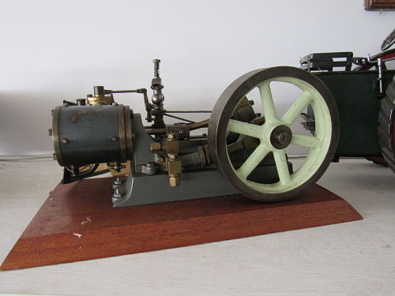

Stock #103 Stuart No.9 MA051

#105 Tangye-type mill or factory engine. 1 ½” bore, 1½” stroke. Built circa 1910 in Nutley, East Sussex, England, by a Mr. Winkle, who ran a small bicycle shop. All parts are of remarkably fine quality and include: valve chest; top lubricator; displacement lubricator; draincock. A unique model; no duplicates are known to exist. Design features recall the full-size Lane engines of the late 19th Century.

Mahogany base. 16” L, 7 5/8” H, 8½” W. $500

#106 Late 19th Century single-cylinder, reversing, vertical winding engine. Rather unusual protruding piston rod extension on top of cylinder head; main stop valve; elaborate split-bronze bearing in the rare, "solid bar" Stephenson reversing linkage; elegant cylinder supports; balanced crank. Built by John D. Cooke, an engineer of Liscaerd, Cornwall, whose many projects included design of engines of this type for use in Cornish tin mines; his notebooks show sketches of this design. Mounted on an oak base. 14½”" H, 6½” W, 7" L. $1125

#107 Mid-19th Century single-cylinder, vertical, reversing Nasmyth engine. 1 3/ 8 11 bore, 2½” stroke. Draincocks; screw-operated Stephenson reversing gear; disc crank; open-bed frame. James Nasmyth, famed for his invention of the steam hammer, developed this engine design in the 1830s and used it to power his first steam hammer of 1839. this model, built between 1865 and 1870, may have been a "salesman's model" for the Nasmyth Works. Wood base. 13 ¼ "H, 6½” W, 6½” L. $1125

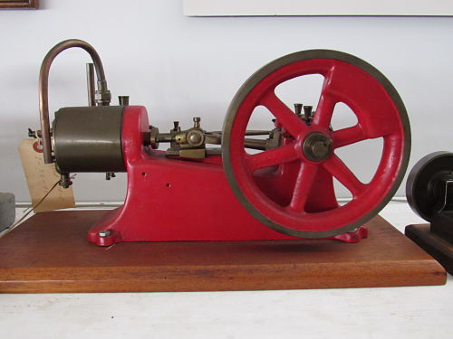

Stock #105 Tangye MA053

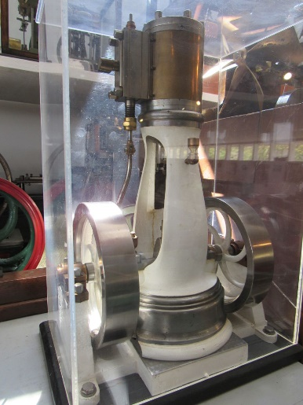

Stock #107 Nasmyth MA034

#108 Marine, triple-expansion, reversing engine. Cylinders are 7/8”, 1 1/8” and

1½” bores, l" stroke. Cylinder draincocks; screw-operated slotted-link Stephenson reversing gear; balanced crankshaft; intermediate and low-pressure crosshead-driven circulating and condenser pumps; turned front-cylinder columns. Probably a model of engines used for Thames River passenger or tug boats. Maker unknown, but design details suggest a date circa 1900. 9 ½” L; 7” H, 4 5/8” W, in glass case

11 ¾” L, 9 7/8” H, 8 3/4" W. $1600

#109 A modern, non-operating model of an overtype portable engine. The design is reminiscent of that patented by the Wood & Mann Steam Engine Co., of Utica, New York in January,1865. It differs from the practice followed in the full-size engine in that the cylinder is of the oscillating rather than the fixed type; this probably reflects the ease of producing an oscillating cylinder. Otherwise, the details are of high quality; all brass construction. 4 ½” L, 6 5/8” H, 1 7/8” W. $150

#110 Crossed out on copy.

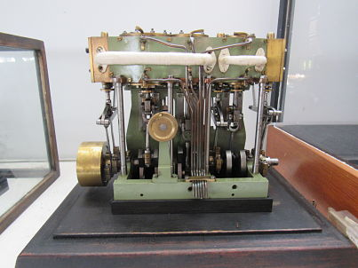

Stock #108 Marine Triple MA060

#111 A collection, extremely rare, of fire-fighting apparatus of the late 19th Century. These models were built by Talfourd of London in 1888 for the Metropolitan Fire Brigade of London Museum. The four items can be purchased individually but obviously make more display sense as a group, whose price is $4,200. Individual prices follow description of each item.

Item A. A Shand-Mason type steam fire engine complete with alcohol-fire boiler and single-cylinder steam pump with scotch-crank. Fittings include: suction hose with filter; firing irons; delivery hose with nozzle; ladders; grab ropes; two copper lamps; fully harnessed matched team of fire horses; whip. 15½" L, 7 ½” H, 5" W. $2150

Item B. Escape ladder/personnel cart drawn by fully harnessed matched team of fire horses. Complete with elevating escape ladder that extends to 50", mounted on wheels, removable from cart via ramps that secure the ladder to the cart-body; small ladder; hand brake; two copper lamps; elevating key to activate ladder mechanism. 18" L, 8½" H, 5" W. $1500

Item C. Complete escape ladder with life-saving cloth chute attached; ladder extends to 30"; tool box; auxiliary ladder. 15" L, 7" H,3 ½” W. $750

Item D. Hand cart with spare lamps, ladder, trestle, spare harness, coiled lines, block and tackle. 6½" L, 3½” H, 3¼” W. $100

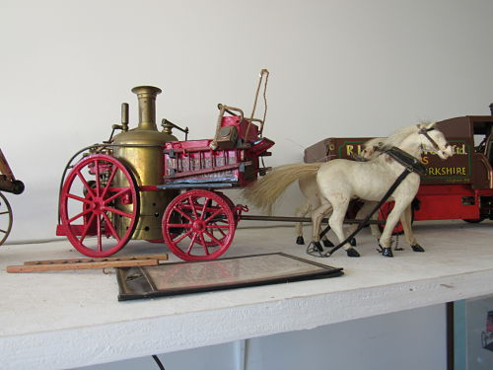 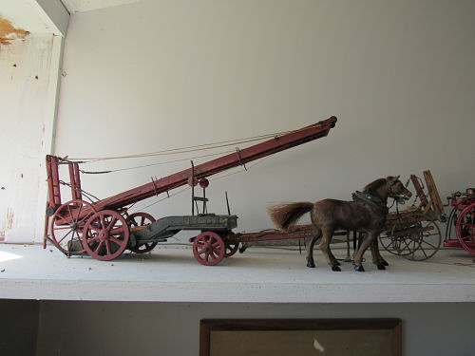

Stock #111A Fire Engine MA048 Stock #111B Escape Ladder MA046

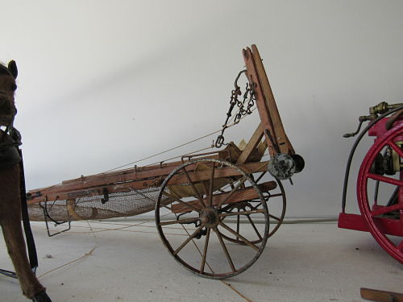

Stock #111C Escape Ladder MA047

#112 Extremely rare, fine quality, accurate and detailed model of a Ruston & Proctor single-cylinder, two-speed, four-shaft, general purpose and agricultural traction engine. Scale: 1” = 1’. Built circa 1905. Special details include: alcohol fired copper boiler with twin safety valves; pressure gauge; three-cock water gauge; auxiliary fire box clack valve for the spare separate pump; valve chest and cylinder lubricators; trunk-type crosshead guide; Stephenson link-gear; eccentric-driven feed pump with air dome and bypass cock; balanced crankshaft; sprung front axle swiveling perch-bracket towing hitch; belly tank with steam water-lift; cable and cable drum with pin clutch; cab-controlled cylinder draincocks and ashpan; damper door; differential; hand brake; sprung seat. 20 " L, 12 5/8" H, 8 3/4" W. Can be steamed. $4500

#113 Late 19th Century Tangye -type mill or factory engine. l" bore, 1 3/8" stroke. Enclosed crosshead trunk. Simplified by unknown maker to essential elements in handsomely machined steel. 7 ½” L, 4 ¼” H, 4 3/8" W. $75

#114 Early 20th Century Tangye-type horizontal mill or factory engine. Semi­ enclosed crosshead trunk with lubricator. l " bore, 3" stroke. Draincock; highly detailed steam supply stop valve; reservoir lubricator for valve chest; split­ bronze bearings; crankshaft with slotted-drive pulley; mounted on simulated shop floor with safety railing. 16 3/4" L, 7 7/8” H, 8 1/16 W. $695

#l115 Single-cylinder, horizontal factory or mill engine. 7/8" bore, l " stroke. Lubricators on crosshead, connecting rod and crankshaft; automatic lubricating pump with reservoir for slide valve chest; finely detailed crankshaft; split-bronze bearings; mahogany base. Late 19th Century. 15 ¾” L, 7 ¾” H, 7 5/8” W. $425

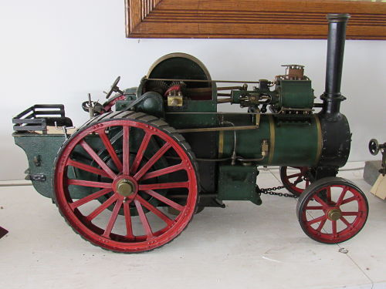

Stock #112 Traction Engine MA050

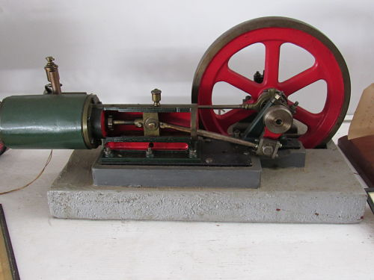

Stock #114 Tangye MA052

#116 An electrically fired boiler with integrally mounted, single-cylinder oscillating engine. Brass boiler; water gauge; combination filler plug/safety valve; whistle. Heating coil shielded by asbestos arch. Mounted on wood plaque. Heavy duty power line. Manufactured circa 1950 by the Jensen Manufacturing Company in Pennsylvania, this is labeled Model 35, 115 volts AC/DC, 450 watts, 4 amps. 9” L, 10" H, 5 1/2” W. $65.

#117 Crossed out on copy.

#118 An exhibition quality, double-crank, compound Burrell-Aveling four-shaft showman's road locomotive, built to l ½” scale circa 1905 by B. A. Norris of Newton Abbot, Devonshire. (Mr. Norris owned a full-size Burrell and a full-size Aveling, liked features of each, and took four years to build this model which combines aspects of both machines.) The model is complete with a fully riveted steel and copper boiler with all normal fittings. Engine details include: full Stephenson link motion reversing; Pickering governors; twin-displacement lubricators; eccentric-driven feed pump with bypass and disc flywheel. Chassis fittings include: lamp brackets; water lift; brass "barley sugar" and "onion" twisted canopy supports; canopy with light bulbs energized by dynamo on forward-mounted bracket; hand feed pump; hand brakes on flywheel and rear drum; bucket; license holders; fretted brass name and number plates; firing tools; belly tank and injector. $5175

#119 A rare l" scale model of a "cross-boiler" under-type Yorkshire steam waggon, or steam lorry, built by C. Griffiths at the turn of the century. Complete with an alcohol-fired, horizontal, water-tube transverse boiler, this model's boiler has all normal fittings plus brass cladding straps. Chassis fittings include: a longitudinal, single-cylinder, double-acting engine with slip-eccentric reverse; hand feed pump; working Ackerman steering; full leaf springs; fretted brass name-plate, "Ella." Finished in Yorkshire Waggon Company brown, red chassis, gray interior of open cargo body. $1675

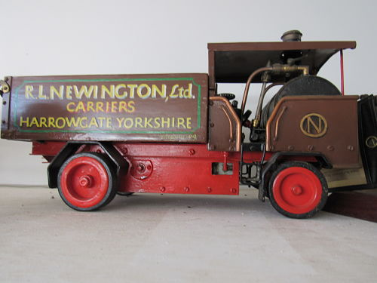

Stock #119 Truck MA049