Dear Exhibitor,

You are cordially invited to join us at Mystic Seaport Museum for the 28th Annual Antique Marine Engine Expo on August 17th and 18th, 2019. All pre-1973 electric, gasoline, and diesel marine engines are welcome, including boats with pre-1973 engines. Steam engines and marine models are welcome, regardless of age.

We respectfully ask that you register by July 31st, 2019 so we can ensure space for your exhibits. We try hard to give this Expo a professional appearance and specialized display cards make it possible for our visitors to better understand what they are seeing with each of your fine examples of early marine engines, boats or models. Packets with your personalized name badges (which should be visibly displayed) and other show materials take time to prepare and your early submissions make this possible.

You are welcome to setup your displays on Friday afternoon, or join us when we open the Museum Store Gate for Exhibitors at 7:00 am both days. As you may already know, we open to the public at 9:00 am and hope to have things in place by that time.

For those of you who wish to sell or swap items, tables will be setup in or near the Pole Barn as in prior years. You can rent a table or equivalent space for $20.00. Multiple tables may be rented, or you can share a single table with a colleague.

This year we will feature racing engines and boats. There will be an associated exhibit in the Thompson Building that you will not want to miss. Look for updates on our website, mysticseaport.org.

The Saturday evening activity might include an ad hoc pizza party if there is enough interest. Please check off the box on page 2 of the registration form to let us know of your wishes. We will confirm at Saturday check-in and collect the money (usually about $10-$12) for this at that time.

Please return the enclosed registration form by July 31st, 2019 so we can plan on exhibition space for everyone. Additional forms are available on our website: mysticseaport.org – type Engine Show in the search field in the upper right and Enter.

Send your questions to us at [engineshow@mysticseaport.org](mailto:engineshow@mysticseaport.org), or call and leave a message at: 860-572-5302 ext. 5084, or 860-572-5341 (our volunteers will return calls on Tuesdays).

Sincerely,

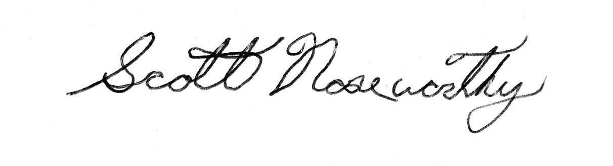

Scott Noseworthy

Engine Collections Manager

**Hotel and Campground information on reverse side.**

**Please reserve your hotel early; August is a busy month in Mystic.**

**(Brackets after hotel name = mileage to Mystic Seaport)**

**HOTEL & MOTEL INFORMATION**

We suggest calling the hotel directly or making your reservations online

Days Inn (1.3), 55 Whitehall Ave., Mystic, CT 06355. Phone: 860-572-0574 / 800-225-3297

Hampton Inn & Suites (1.1), 6 Hendel Drive, Mystic, CT 06355. Phone: 860-415-8155 / 888-370-1940

Hilton Garden Inn Mystic/Groton (7.8), 224 Gold Star Highway (Rte. 184), Groton, CT 06340,

Phone: 860-445-6800 / 888-370-1942

Holiday Inn Express (0.8), 6 Coogan Blvd., Mystic, CT 06355. Phone: 860-572-7001 / 800-719-5540

Howard Johnson Inn (0.7), 253 Greenmanville Ave., Mystic, CT 06355. Phone: 860-536-2654 / 800-221-5801

Hyatt Place Mystic (0.7), 224 Greenmanville Ave., Mystic, CT 06355. Phone: 860-536-9997 / 855-516-1090

Inn at Mystic (0.7), 3 Williams Ave., Mystic, CT 06355. Phone: 860-536-9604

Mystic Hilton (1.1), 20 Coogan Blvd., Mystic, CT 06355. Phone: 860-572-0731 / 888-370-1934

Mystic Marriott Hotel & Spa (4.9), 625 North Road / Route 117, Groton, CT 06340. Phone: 860-446-2600 /

888-236-2427

QualityInn (1.2), 48 Whitehall Ave., Mystic, CT 06355. Phone: 860-980-3257 / 800-521-2121

Residence Inn Mystic Groton (1.2), 40 Whitehall Ave., Mystic, CT 06355. Phone: 860-536-5150 / 888-236-2427

Steamboat Inn (0.9), 73 Steamboat Wharf, Mystic, CT 06355. Phone: 860-536-8300

Taber Inne & Suites (1.0), 66 Williams Ave., Mystic, CT 06355. Phone: 860-536-4904 / 866-822-3746

Whaler's Inn (0.6), 20 East Main St., Mystic, CT 06355. Phone: 860-536-1506

For a list of local Bed and Breakfasts, please check the web site of the ctvisit.com. Click on “Stay”, then B & B’s/Inns, then “Mystic Country”

**CAMP GROUND INFORMATION**

Seaport Campground (2.3), 45 Campground Rd. (Rte. 184), Old Mystic, CT, 06372. Phone: 860-536-4044

Website: www.sunresorts.com/Community/SPO.aspx

Mystic KOA (8.7), 118 Pendleton Hill Road, North Stonington, CT, 06359. Phone: 860-599-5101 / 800-562-3451

Website: www.koa.com/campgrounds/mystic

Strawberry Park Resort Campground (14.7), 42 Pierce Rd., Preston, CT, 06365. Phone: 860-8861944 / 800-356-2460

Email: [camp@strawberrypark.net](mailto:camp@strawberrypark.net) / website: www.strawberrypark.net